COMMERCE AND MANAGEMENT
ASSOCIATION REPORT
2016-17

CONTENTS

SlNO TITLE PAGE NO
1 Association Report - A Curtain Raiser 3
2 Commerce and Management Association Inauguration 4
3 Employability Enhancement Programs 5
4 Path Finders for Higher Studies 6
5 Research Orientation Sessions for P.G Students 7
6 Value Evaluation and Counselling Sessions 9
7 Onam Celeberations 10
8 The Tutelage 11
9 The Mega Event – Kaleidoscope 11
10 Students Achievements 13
11 Conclusion 14
12 Annexure:
Students Achievements Report

COMMERCE & MANAGEMENT ASSOCIATION
ANNUAL REPORT: 2016-17

A CURTAIN RAISER

“A MAN ONLY LEARNS IN TWO WAYS, ONE BY READING AND THE OTHER BY ASSOCIATION WITH SMARTER PEOPLE.”
– WILL ROGERS

True indeed are the lines read above and that was exactly the motive behind each single event organized by the commerce and management association for the year 2016-17.
So, with immense pleasure we place on record the annual report of Commerce and Management Association for the year 2016-17.
The year started off with the welcoming of our new HOD Prof.Dr. J. Nalini. Under her able guidance, we had no looking back. There was a series of activities month after another opening new vista to the student community of commerce and management. But great things happen when there is a great team because Together Everyone Achieves More. We had in our team:

Teacher in Charge : Smt. Rani M Susan, Faculty, BBA;

Secretary : Mr. Aravind S Krishnan, 3rd B. Com

Executive Committee Members & Kaleidoscope Committee Members (P.T.O)

EXECUTIVE COMMITTEE MEMBERS: |  |  | KALEIDOSCOPE
 |  |  | Faculty-in-Charge - Prof.Manoj Narayanan
 |  |  | STUDENT COMMITTEE MEMBERS:
BATCH | STUDENT IN CHARGE | POST | BATCH | STUDENT IN CHARGE | POST
M2 Com. | Tony Jose | Representative | M2 Com. | Chandapillai M Abraham | P.G Convenor
 | Shereena M.R | Representative | D3 B.Com | Anto C Biju | U.G Convenor
M1 Com. | Serina Thomas | Representative |  | Alfred Jayan | Fund Manager
D3 B.Com | Cherish Levi John | Joint Secretary |  | Jayalakshmi G | Treasurer
 | Alishamol Mathew | Representative | D3 BBA | Alex William Panicker | U.G Convenor
D3 BBA | Tom Jo Gracen | Joint Secretary |  | Issac… | Fund Manager
 | Devika Raj | Representative
D2 B.Com | Ajith P.R | Representative
 | Sreelakshmi K | Representative
D2 BBA | Kuriakose P Kurian | Representative
 | Anjaly T Kenson | Representative
D1 B.Com | Vishnu C Prakash | Representative
 | Veena R Nair | Representative
D1 BBA | Adarsh A Kumar | Representative
 | Archana Sudarshan | Representative

Detailing about the activities of the association, each single event was focused at catering to the variety needs of the student community. As such the list of activities for the year were:

- Commerce & Management Association Inauguration

Every formation demands an inauguration and so with all splendour the Commerce and Management Association’s Inauguration and Cultural Programme with the theme “Unity in Diversity” took place on 3rdSetember, 2016.

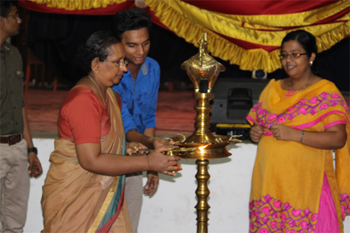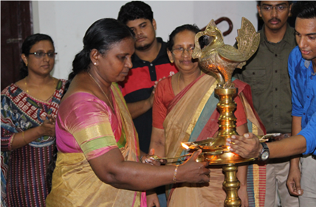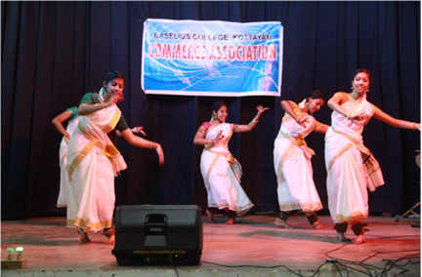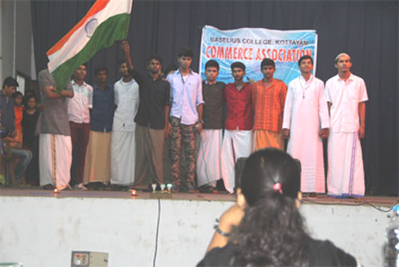

- Employability Enhancement Programs

Earning a decent livelihood is an indispensable urge in every human being. But what are the ways that lead to the same is a question mark. Putting this in mind a few programs were chalked out by the association catering to the employability requirements of the students, especially the final years, which included:

- A Session on Practical Accounting & Taxation by Mr. Omanakuttan S on 8th June,2016.

- Bank Recruitment Coaching – for D3 B.Com Students by SB Global Educational Resources Pvt.Ltd. on 15th July, 2016.

- Orientation Session on Professional Accounting for B.Com Students by Sri. Harikumar of Amal Jyothi College on 19th July, 2016.

- A Session on Qualities of an Accountant & Issues in Practical Accounting dealt by Mr.K.B. Somanathan, Institute of Accountants, Kottayam on 16th August, 2016.

- Seminar on Demat and Mutual Fund Trading Conducted by Sri. GireeshBabu and Smt. Jayalakshmi G. Nair, Stock Holding Corporation of India Ltd., Kottayam on 6th October, 2016.

- A session on IFRS by Sri .Rakesh Sarma, ISDC, on 3rd November, 2016.

- Two day NET Coaching for M.Com final year Students of this college and 19 M.Com Students of CMS College under the guidance of Sri. Geevarghese Mathews and Sri. Dennis Jose, of the Walnut Organisation of Advanced Training, Kottayam held on 18th and 19th January,2017.

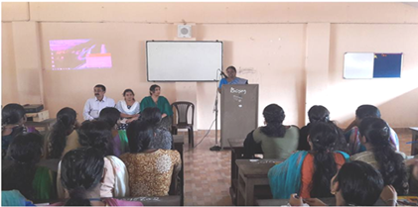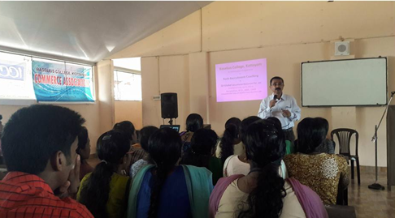

- Path Finder for Higher Studies

For some, job may be the prime motive behind learning, while for some others it isnot just a job that suffice instead they search out for higher avenues where they could truly exhibit their talents and qualities. Giving a focus to this category of student community the programs that ware carried out were:

- Presentation from Mr.Jikku Abraham on CAT for D3 B.Com and BBA students on 21st June, 2016.

- Orientation Programme for D1 B.Com on “Career as Company Secretary” led by Smt. Chitra Anantharaman, Deputy Director, ICSI-SIRC, Chennai along with Ms.Anna Mathew and Ms. Reeba on 25th October,2016.

- Orientation on CMA(USA) by Sri. Balanchandran S, Vidyarapa School Cochin, on 4th November, 2016.

- Orientation on CPA and Management Course by Sri. Dennis S, Infozia, Kottayam, on 4th November, 2016.

- Orientation on MBA courses on 12/11/2016 by Sri. Daniel John, Director and Sri. Mufeed D.V, Global Institute of Integral Management Studies (GIIMS). The session was also illuminated with a Best Manager Competition in which Harikrishnan K.V of B.Com final year bagged the Best Manager title.

- Orientation on ACCA by Sri. Alex Tom Joseph, Logic School of Management on 12/01/17.

- Orientation on CMA(USA) by Sri. Nandakumar Menon, IAM Business School on 16/01/17.

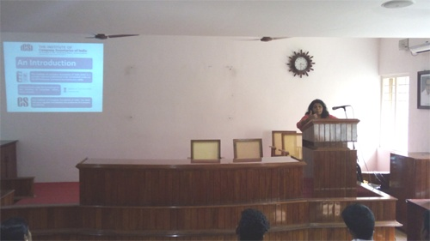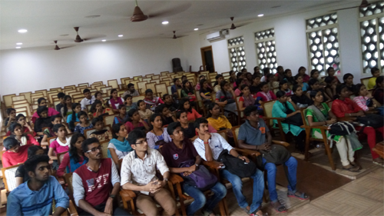

- Research Orientation Sessions for P.G Students

The advantages of research extend beyond having an impressive degree certificate. Through detailed research, students develop critical thinking expertise, as well as effective analytical, research, and communication skills that are globally sought-after. Today research is an inevitable part of higher education and students need to be thoroughly oriented on this fact. So as a stepping stone, the research orientation sessions that was conducted by the association for the P.G students were:

- A session on “Review of Literature for Projects” dealt by Asst. Prof.Diana Ann Issac, M.A College, Kothamangalam on 19/07/16.

- Session on “Research Design” by Asst. Prof. Sr. Usha A, St. Joseph’s College, Alapuzha on 22/07/16.

- Class on the topic “Research Methodology and Application of SPSS Software” handled by Prof. Biju Joseph, St.Pius X College, Rajapuram, Kasargode on 5th and 6th of August, 2016.

- Class on “Transactional Analysis”, by Ms. Asha Thomas, Research Scholar, Technological University, Delhi on 06/01/17.

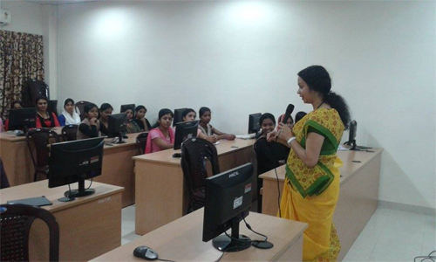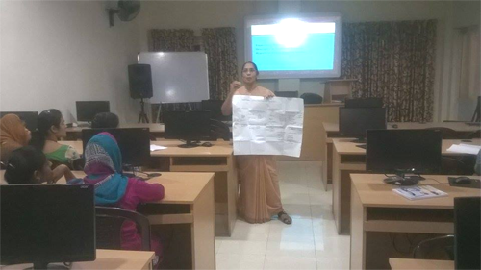
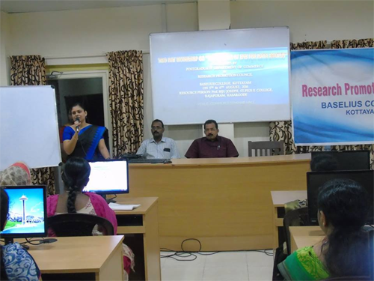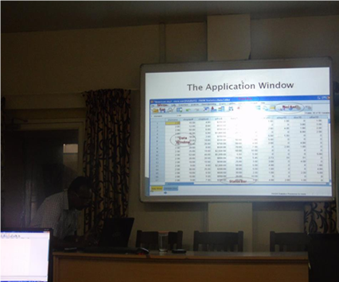

- Value Evaluation & Counselling Sessions

“It is not hard to make decisions when you know what your values are.” – Roy E. Disney.
The youth of today are fumbling when it comes to taking right decisions, and here lies the importance of value enhancement. With pure and clear values, we are always on the right path when it calls for taking the right decision. The commerce and management association were not only concerned with the materialistic development, but giving due regard for the value enhancement of students the value education events that were charted out for degree level students included:

- Orientation and Value Evaluation Session for D3 B.Com and BBA students on 28th June, 2016 handled by Mr. Siju Thomas Alencherry, MBA, ATP who is the chief operating officer of the counselling center by the name “Wings to Win”, Ernakulam.

- Orientation and Counselling session for D1 B.Com and BBA students as a part of inducting them into the college life. The session was led by Mrs. Arathy V. Dev, Seethalayam, Kottayam on 29th July, 2016.

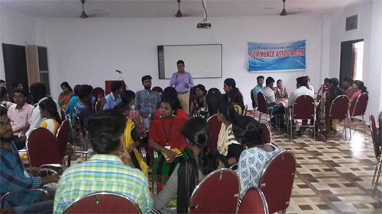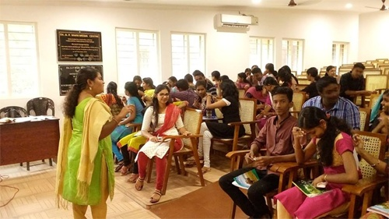
Onam Celebrations

The festivity of Onam was celebrated in a simple yet entertaining manner on 7th of September, 2016. Students actively participated in variety entertainments like “Sundarikku Pottu Thodal”, “Musical Chair” and so on. The association also won 2nd prize in the pookalam competition.

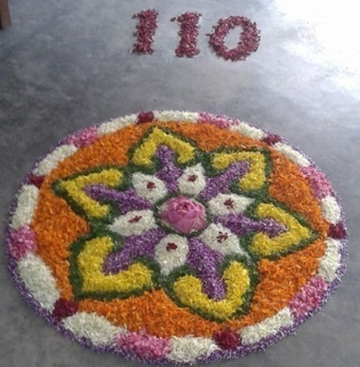

- The Tutelage

Every college is a second home to its students and every home ensures the safety of its ward. So, in view of the ever-increasing cybercrimes wherein most of the times the youth happens to be the victims, a tutelage session was conducted by the commerce and management association on 14/03/2017 from 2.00 pm – 4.00 p.m. The said session was led by the Deputy Superintend of Police, Vigilance and Anti-Corruption Bureau, Eastern Range. The topic for the session was “An Awareness Program on Cyber Crimes.”
An introduction to Vigilance and Anti-Corruption application was also given by Mr. Toby and Mr. Sobith the vigilance officers of the eastern range.

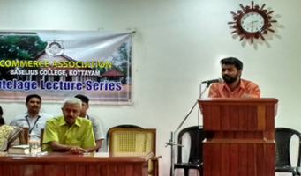
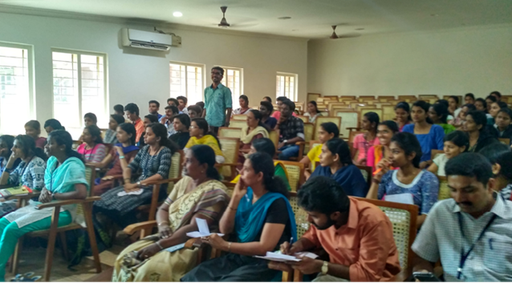

- The Mega Event – KALEIDOSCOPE

February was the month in which the yearlong toil of students and teachers was materialised with the successful hosting of Kaleidoscope – the Prestigious Inter Collegiate Competition of P. G Department of Commerce and Management. The gala event was hosted under the eminent leadership of Prof. Manoj Narayanan on 11th of February and had competitive events like Prabhavam, Smritirangam, Sargam and Dayanam with participation from various colleges in and around Kottayam. The Paper Presentation part of Kaleidoscope (Praajnikam) was held on 28th February, 2017 with a participation of 32 students from various universities of Kerala.

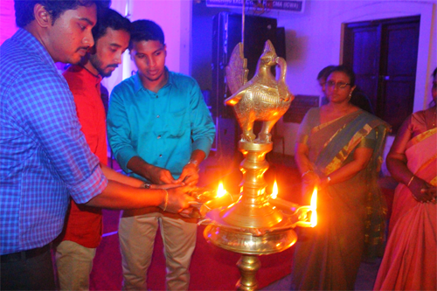
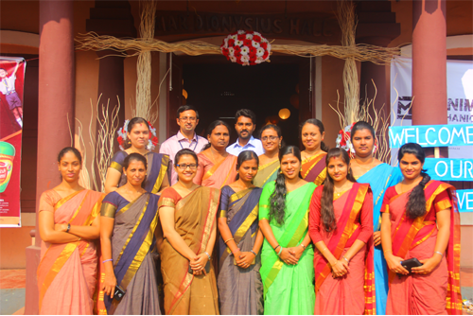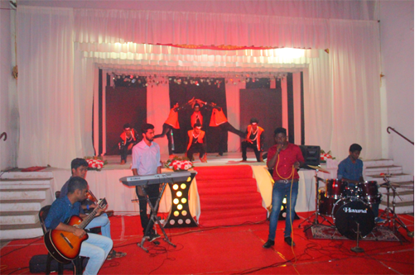
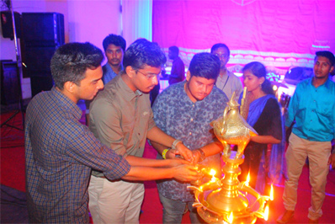
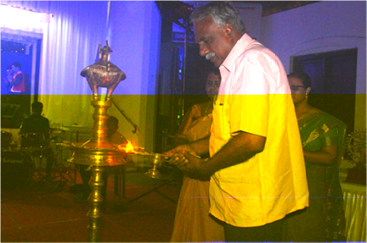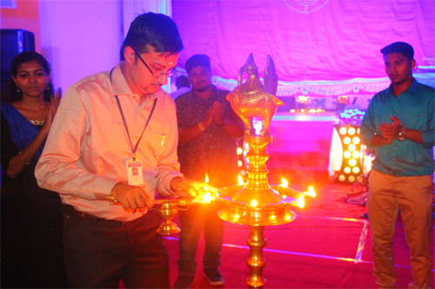

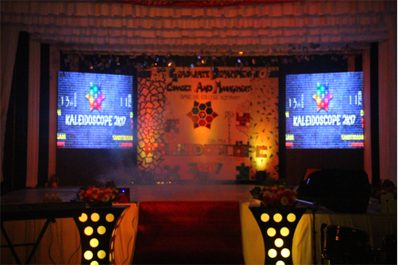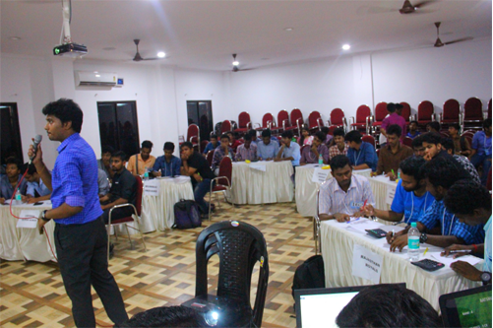

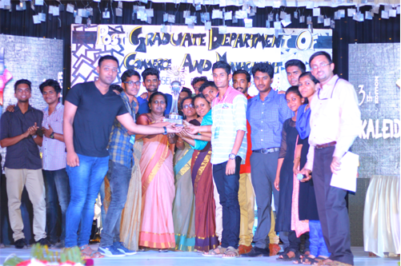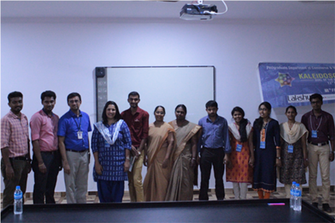

- Student’s Achievements

Apart from the numerous academic activities carried out in the academic year, the students of the association actively participated in more than 20 inter collegiate management fest competitions and won around 100 prizes with various position titles. The students also secured ‘

- OVERALL CHAMPIONSHIP IN THE INTER-COLLEGIATE COMMERCE FEST (VIDYASTRA 2K17) OF ASSUMPTION COLLEGE, CHANGANASSERY.

- OVERALL CHAMPIONSHIP IN THE COMMERCE FEST (GITS BLITZ) OF ST. GITS COLLEGE, PATHAMUTTOM.

- OVERALL CHAMPIONSHIP IN THE COMMERCE FEST (MANGALWAR) OF MANGALAM COLLEGE, ETTUMANOOR, KOTTAYAM.
The detailed student’s achievements report for the year 2016-17 is being attached in the pursuing pages.

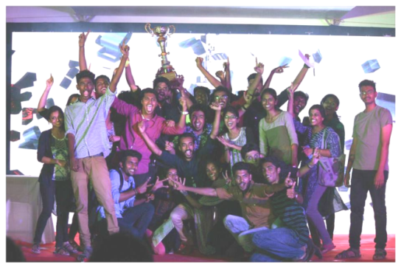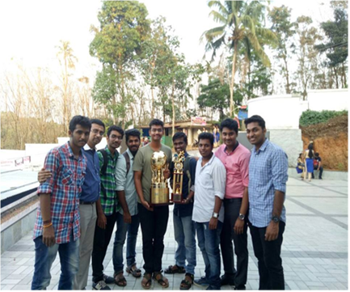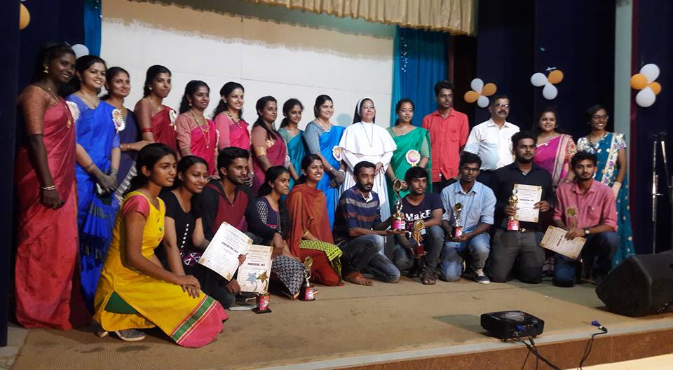

- In Conclusion,
it would be worthwhile to mention that by God’s grace the academic year 2016-17 was indeed a fruitful one for the Commerce & Management Association. Looking forward to more such eventful years and thanking each and every member of the teaching fraternity and student community of the Commerce and Management Association for all their big and small supports, yours,

Prof. Dr. J. Nalini, Smt. Rani M Susan, Mr. Aravind S Krishnan,
Head of the Department. Teacher in Charge. Secretary.

